**Python Programming**

**Lab Assignment-1**

**Team ID:** 10

**Student 1:** Devi Prasad Kada, Class ID: 13

**Student 2:** Sushmanth Makkena, Class ID: 16

**Introduction:**

In this lab assignment 1 we worked on different programs like finding a unique letter which is not repeated in the string and also developed a code which removes all the content from file1 from file2.

**Objectives:**

Finding the unique character in a string which has repeated characters.

Used the subtraction rule to find the list of students who are taking only particular class.

We also used splitting function, reading function and looping in files.

We also applied special built-in methods for creating the Hospital Admission System.

**Approaches:**

We have implemented the program by using different classes, constructors, used the concept of inheritance, creating of instances.

With the help of beautifulsoup lib we downloaded a webpage contains a table and parsed it.

**Workflow:**

Question 1:

Here dictionary stores the count of each character.

**Program code:**

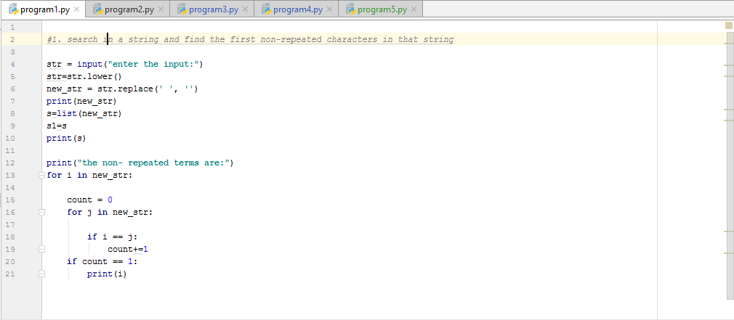

Output:

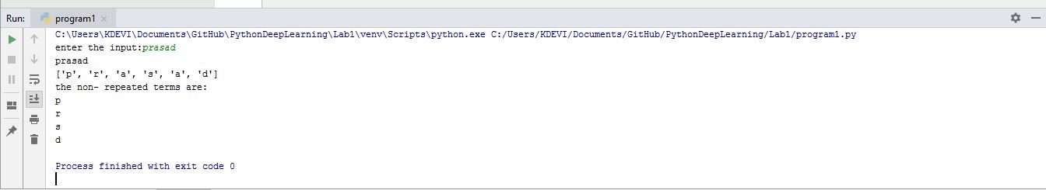

Question 2:

And then we use looping file 1 list and check whether file 1 is present in file 2

Program code:

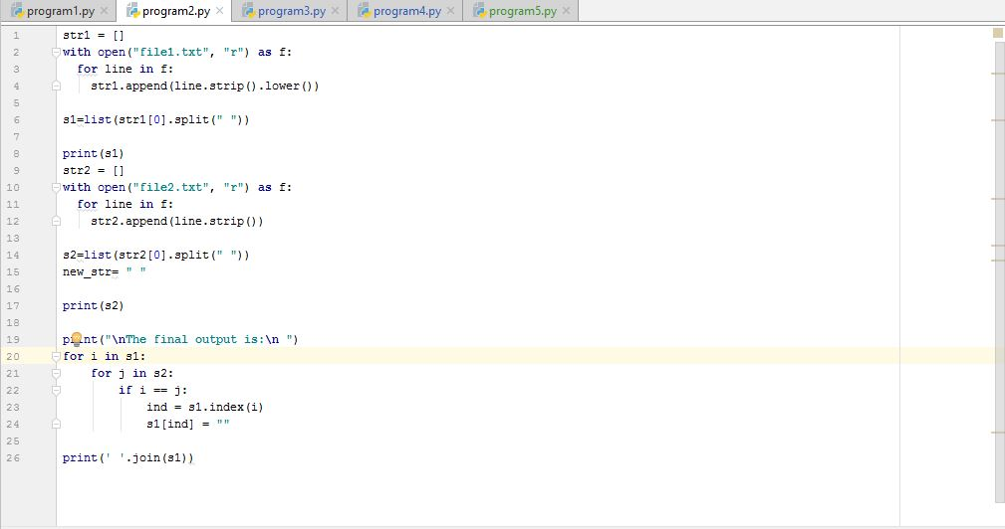

Output:

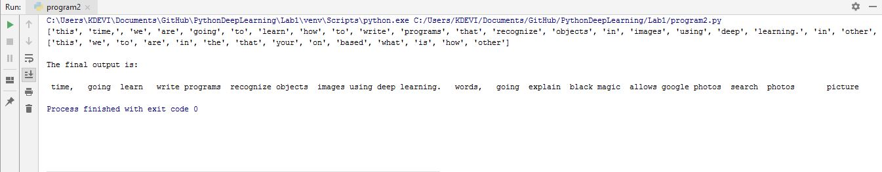

Question 3:

We subtracted the student who took python from the students who took web.

Program code:

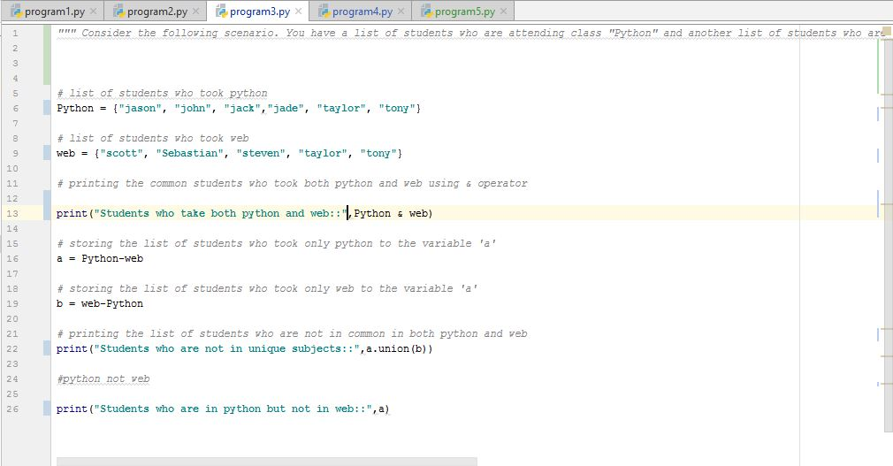

Output:

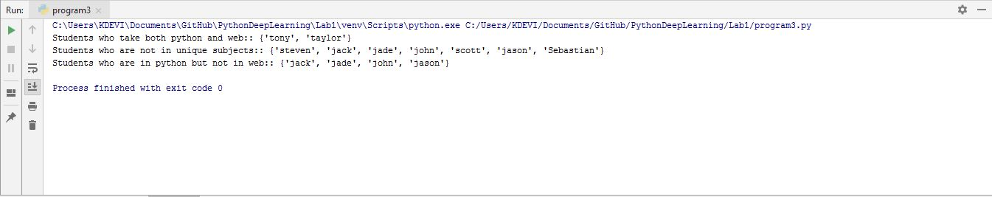

Question 4:

We have initialized 6 classes (hospital, patient, doctor clerk, nurse, book), used __init__ constructor in all the classes. We also used inheritance concept.

Code snippet:

A screenshot of a social media post

Description generated with very high confidence

A screenshot of a social media post

Description generated with very high confidence

Multiple inheritance

A screenshot of a social media post

Description generated with very high confidence

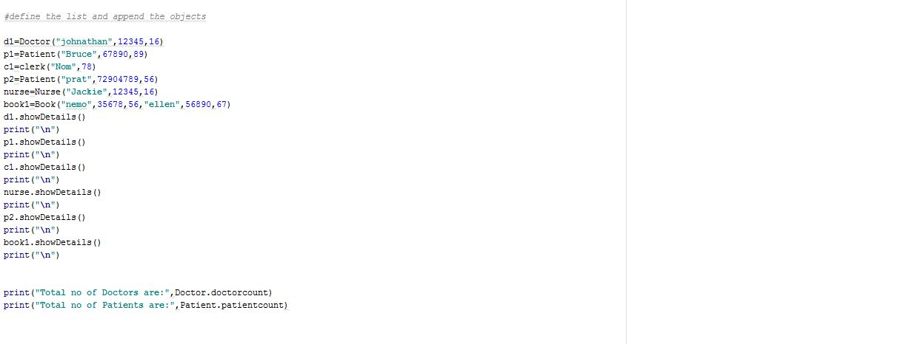

Output:

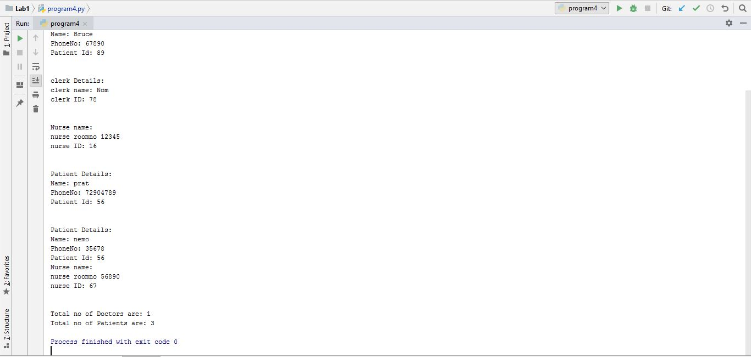

Question 5:

We are importing url and request library and also assigning link to the variable.

soup = BeautifulSoup(getLink, "html.parser")

Code snippet:

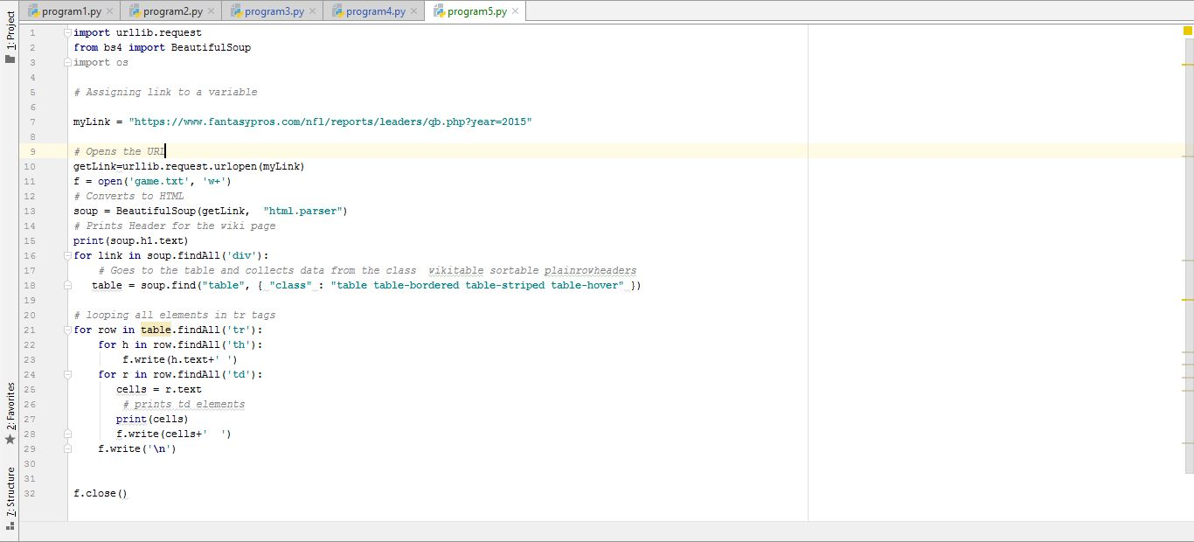

Output:

